

V 1.0
March 2026
Functional & Technical XStep Specification
SMPL: Probe Standardization Time Stamp

Table of Contents
Functional Requirements 3
1 Purpose 3
2 Overview 3
3 Reasons for developing 4
4 Authorization 4
5 Assumptions/ Dependencies 5
6 Security Objects 5
7 Development Type 5
8 Processing Options 5
9 Functional Mapping Rules for Fields 6
10 Validation Checks 6
General Technical Specification 7
11 Technical XStep Layout Design 7
12 XStep Technical Specification 7
12.1 Parameters: 7
12.2 Development Architecture 11
12.3 Parameter Configuration 12
12.4 Technical Implementation 13
13 Function Module(s) 14
14 Pseudocode 15
15 Configuration Specifications 19
16 Test Scenarios 19
17 Document References 22
18 Revision History 22

Functional Requirements

Purpose
This document outlines the functional and technical design, along with the configuration specifications for the XStep “SMPL: Probe Standardization Time Stamp”.

Overview
The SMPL: Probe Standardization Time Stamp allows operators to select the specific $pO_{2}$ probe used to calibrate dissolved oxygen sensors to a 100% saturation baseline once process readings have stabilized. During this step, the operator identifies the active probe and records the exact time of standardization to ensure process traceability and sensor accuracy before moving to the next phase.
The XStep contains the following main input parameters:
- IV_HEADER - This can be changed in SiMPL MBR to display specific header text for the XStep
- IV_INSTR - This can be changed in SiMPL MBR to display a specific set of instructions for the XStep that will be displayed below the header
- IV_TITLE1 - This can be changed in SiMPL MBR to display the specific field label for the value being recorded. By default it is set to “Probe” but can be changed to anything applicable
- IV_TITLE2 - This can be changed in SiMPL MBR to display the specific field label for the value being recorded. By default it is set to “Record Current Time” but can be changed to anything applicable.
- IV_TITLE3 - This can be changed in SiMPL MBR to display the specific field label for the value being recorded. By default it is set to “Date” but can be changed to anything applicable.
- IV_TITLE4 - This can be changed in SiMPL MBR to display the specific field label for the value being recorded. By default it is set to “Time” but can be changed to anything applicable.
The XStep has additional functionality for row addition in the event more entries are required.
Functional Design
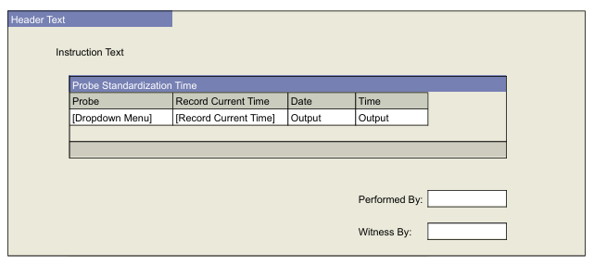

Reasons for developing
The SMPL: Probe Standardization was developed to keep record both the standardization probe selected and time exact time stamp the 100% $pO_{2}$ saturation calibration. Additionally the developed process steps allow for compliance with the referenced SOP standards. This functionality ensures accuracy and full audit traceability for quality control and regulatory compliance.

Authorization
N/A

Assumptions/ Dependencies
 | Assumption
1 | Master Data has been set up correctly
2 | The function module retrieves the current date and time successfully

Security Objects
Object Name | Description
Signature validation | Optional

Development Type
Development Type: |  | Report |  | Interface |  | Conversion |  | Enhancement
 |  | Form |  | Workflow |  | Portal |  | EDI
 |  | Screen |  | Data Cleansing |  | Data Dependencies
 | X | Other: | XStep

Processing Options
Processing Options
Processing Mode: |  | Batch | X | Online
Frequency |  | Annually |  | Quarterly |  | Monthly |  | Weekly
 |  | Daily |  | Minutes
 | X | Other: | Executed per EBR

Functional Mapping Rules for Fields
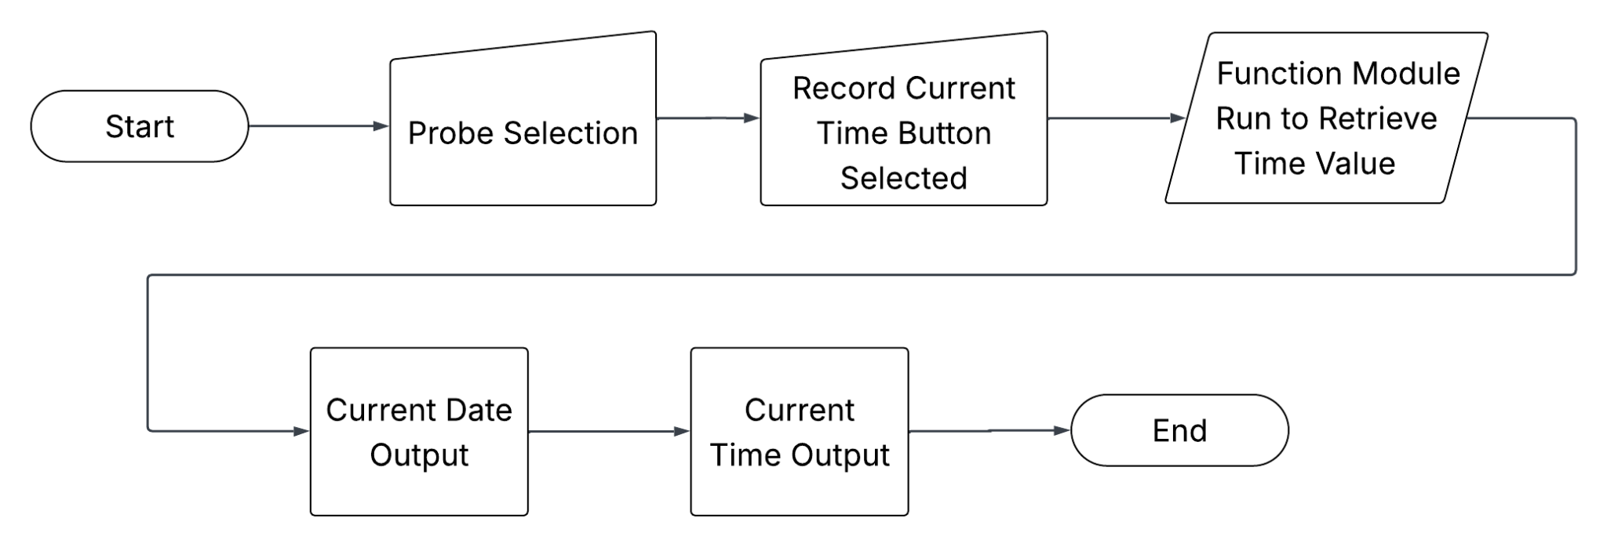

Validation Checks
Error Handling
Error | Action

General Technical Specification

Technical XStep Layout Design

XStep Technical Specification

12.1 Parameters:

12.2 Development Architecture

12.3 Parameter Configuration
Configuration Parameters
Output and Local Parameters
XStep Dependency Configuration

12.4 Technical Implementation
Function Button Integration
Field Behavior and Flexibility
Add description of logic if any
Signature Validation Mechanism
Applicability and Execution Control

Data Integration and Traceability

Function Module(s)
Function: /SMPL/PPPI_FM_SET_DATE_VALUE
Import Parameters:
Parameter Name | Associated Type | Short Text
IV_DATE | DATS | N/A
Export Parameters:
Parameter Name | Associated Type | Short Text
EV_DATE | DATS | N/A

Function: /SMPL/PPPI_FM_SET_TIME_VALUE
Import Parameters:
Parameter Name | Associated Type | Short Text
IV_TIME | TIMS | N/A
Export Parameters:
Parameter Name | Associated Type | Short Text
EV_TIME | TIMS | N/A

Function: /SMPL/PPPI_FM_INITIAL_ACTIVE
Import Parameters:
Parameter Name | Associated Type | Short Text
IV_ACTIVE | CHAR1 | N/A
Export Parameters:
Parameter Name | Associated Type | Short Text
EV_ACTIVE | CHAR1 | N/A

Function: /SMPL/MBR_DEP_CHECK_ACTIVE
Import Parameters:
Parameter Name | Associated Type | Short Text
IM_CONTROL_RECIPE | POC_DOCID | N/A
IM_PHASE | VORNR
IM_AUFNR | AUFNR
IM_STEP_UUID | /SMPL/MBR_SOG_UUID
IM_PLANT | WERKS_D

Export Parameters:
Parameter Name | Associated Type | Short Text
EV_ACTIVE | CHAR1 | N/A

Exceptions:
Exception | Short Text

CONTROL_RECIPE_INITIAL

Pseudocode
Function: /SMPL/PPPI_FM_INITIAL_ACTIVE
1. Initialization
a. Input parameter IV_ACTIVE is optionally provided by the calling logic.
b. Constants gc_yes, gc_no, and gc_inside_range are assumed to be defined globally in the context of the function module.
2. Active Flag Evaluation
a. The function checks if the input value IV_ACTIVE falls within the expected valid range, represented by gc_inside_range.
b. Based on the result:
● If the input value is not equal to gc_inside_range, the XStep is marked as inactive by setting EV_ACTIVE = gc_no.
● If the input value is equal to gc_inside_range, the XStep is marked as active by setting EV_ACTIVE = gc_yes.
3. Output Assignment
a. The evaluated result is returned in the EV_ACTIVE export parameter for use by the calling logic (e.g., XStep configuration, PI sheet rendering).
Additional Notes
● This is a simple normalization function that abstracts how activation flags are interpreted for PPPI XSteps
● The use of constants (gc_yes, gc_no, and gc_inside_range) allows the logic to be aligned with broader application settings or standards.
● Helpful in scenarios where input values may vary but need to result in consistent "active" or "inactive" behavior.
● Input is optional, so defaulting behavior can be configured outside this function.
● This function improves clarity and consistency in determining whether an XStep should be active when rendered in the PI Sheet.
Function: /SMPL/MBR_DEP_CHECK_ACTIVE
1. Initialization
a. Input parameters provide context for determining whether an MBR (Manufacturing Batch Record) step can be activated:
● IM_CONTROL_RECIPE (POC_DOCID) – Control recipe ID identifying the batch instruction.
● IM_PHASE (VORNR) (Optional) – Operation or phase within the process order.
● IM_AUFNR (AUFNR) (Optional) – Process order number associated with the step.
● IM_STEP_UUID (/SMPL/MBR_SOG_UUID) – Unique step identifier (SOG).
● IM_PLANT (WERKS_D) – Plant code for process context.
b. The function first validates that IM_CONTROL_RECIPE is not initial.
● If it is initial, the exception CONTROL_RECIPE_INITIAL is raised.
c. Internal data is initialized:
● lt_ord_sigs: Internal table for storing order signature data from /SMPL/MBR_OR_SIG.
● ls_step_dep: Work area for step dependency data.
● Routine LOAD_INTERNAL_DATA is called to populate internal buffers (g_ord_data-t_ord_deps) using IM_AUFNR, IM_CONTROL_RECIPE, and IM_STEP_UUID.
2. Signature Data Retrieval
a. The function retrieves signature records for the process order from database table /SMPL/MBR_OR_SIG.
b. Selected fields include: AUFNR, SOG_UUID, TYPE, CREATED_DATE, CREATED_TIME, DEST_NAME, SIGN_ID, SIGN_DATE, and SIGN_TIME.
c. Only signatures related to the specified order (AUFNR = IM_AUFNR) are selected.
d. These records are stored in the internal table lt_ord_sigs for later evaluation.
3. Dependency Evaluation
a. The function loops through dependencies in g_ord_data-t_ord_deps where:
● TARGET_UUID = IM_STEP_UUID, and
● DEP_RULE is either gc_perform_before_start_rule or gc_verify_before_start_rule.
b. For each dependency record:
● If the rule is PERFORM BEFORE START, it checks whether the prerequisite step (PREREQ_UUID) has a pending perform signature (gc_perform_signature) with SIGN_ID = abap_false.
● If the rule is VERIFY BEFORE START, it checks whether the prerequisite step (PREREQ_UUID) has a pending verify signature (gc_verify_signature) with SIGN_ID = abap_false.
c. If an incomplete signature is found, the step is marked inactive (EV_ACTIVE = gc_step_inactive).
d. If all prerequisite signatures are complete, the step is marked active (EV_ACTIVE = gc_step_active).
4. Output Assignment
a. The evaluated activation status is returned in the export parameter EV_ACTIVE.
● gc_step_active – All prerequisite steps are completed; the current step can start.
● gc_step_inactive – At least one prerequisite step is incomplete; the current step remains blocked.
Additional Notes
This function determines whether a dependent step in a Manufacturing Batch Record is eligible to start based on the completion of prerequisite steps.
Key Features:
● Evaluates Perform Before Start and Verify Before Start dependency rules.
● Dynamically validates signature data from /SMPL/MBR_OR_SIG.
● Integrates with existing MBR dependency structures via global table g_ord_data-t_ord_deps.
Error Handling:
● Raises CONTROL_RECIPE_INITIAL if the control recipe input is missing.
● Handles empty dependency or signature data without runtime errors.
Dependencies:
● Tables: /SMPL/MBR_OR_SIG (Signatures), g_ord_data-t_ord_deps (Step Dependencies).
● Constants: gc_perform_before_start_rule, gc_verify_before_start_rule, gc_perform_signature, gc_verify_signature, gc_step_active, gc_step_inactive.
● Routine: LOAD_INTERNAL_DATA for initializing order context.
Assumptions:
● All prerequisite steps are recorded in the dependency table.
● Signature records are current and synchronized with MBR step progression.
Activation status is recalculated each time the function is called to reflect live signature data.

Configuration Specifications
N/A

Test Scenarios
Variant 1: Equipment Select
# | Scenario | Expected Result | Actual Result | Pass/ Fail

Document References
Reference No. | Document Title

Revision History
Version No. | Description | Author | Date

